Program: -MechanicalEngg. | Faculty Name :ROBIN BABU | Sem: 4th
Course Title:KOM | Course Code: -B037415(037) | Max Marks- 20

Assignment-II
Note: Each Question carry 4 marks.

1. Define the terms used in Radial Cams with the help of diagram.
2. A cam is to be designed for a knife edge follower with the following data :
1. Cam lift = 40 mm during 90° of cam rotation with simple harmonic motion.
2. Dwell for the next 30°.
3. During the next 60° of cam rotation, the follower returns to its original position with
simple harmonic motion.
4. Dwell during the remaining 180°.
Draw the profile of the cam when
(a) the line of stroke of the follower passes through the axis of the cam shaft, and
(b) the line of stroke is offset 20 mm from the axis of the cam shaft.
The radius of the base circle of the cam is 40 mm. Determine the maximum velocity and
acceleration of the follower during its ascent and descent, if the cam rotates at 240 r.p.m

3.The following data relate to a pair of 20° involute gears in mesh:
Module = 6 mm, Number of teeth on pinion = 17, Number of teeth on gear = 49 ; Addenda
on pinion and gear wheel = 1 module.
Find: A. The number of pairs of teeth in contact;
B. The angle turned through by the pinionand the gear wheel when one pair of teeth is in contact, and
C. The ratio of sliding to rolling motionwhen the tip of a tooth on the larger wheel
(i) is just making contact,
(ii) is just leaving contact withits mating tooth, and
(iii) is at the pitch point

4. In a reverted epicyclic gear train, the arm A carries two gears B and C and a compound gear D - E. The gear B meshes with gear E and the gear C meshes with gear D. The number of teeth on gears B, C and D are 75, 30 and 90 respectively. Find the speed and direction of gear C when gear B is fixed and the arm A makes 100 r.p.m. clockwise.

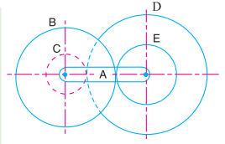

5. A shaft which rotates at a constant speed of 160 r.p.m. is connected by belting to a parallel shaft 720 mm apart, which has to run at 60, 80 and 100 r.p.m. The smallest pulley on the driving shaft is 40 mm in radius. Determine the remaining radii of the two stepped pulleys for 1. a crossed belt, and 2. an open belt. Neglect belt thickness and slip.

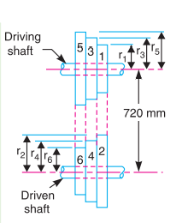

Program: Mechanical Engg | Faculty Name :- Roshan Datt Kashyap | Sem :- 4th
Course Name :- ATD | Course Code : - B037411(037) | Max Marks :- 20

Assignment - II
Note: - Each Question carries four marks.
Draw diagram, graph and comment wherever necessary.
- Explain regenerative cycle. (CO-1, PO-1, Level-2) [4]

- Brief information about Rankine cycle . (CO-1, PO-2, Level-1) [4]

- Explain cooling ponds. (CO-2, PO-1, Level-3) [4]

- Give advantages and disadvantages of any two type of condenser. (CO-2, PO-1, Level-3) [4]

- For 1 – D isentropic compressible flow through duct prove.

dA/A = dV/V (M² - 1)

(CO-2, PO-1, Level-3) [4]

Program: B Tech | Faculty Name: Mr. Praveen Chandrakar | Sem.: VI
Course Name: Fluid Mechanics | Course Code: B037411(037) | Max Marks: 20

Assignment- II
QN | Question | CO | PO | Level | Marks
1 | Drive the continuity equation in 3-D. | 1 | 1 | 1 | 4
2 | A 300 mm diameter pipe carries water under a head of 20 meters with a velocity of 3.5m/s. if the axis of the pipe turns through 45⁰ ,find the magnitude and direction of the resultant farce at the bend. | 1 | 8 | 2 | 4
3 | Define: Mach Number, Weber Number, Euler Number & Kinematic Similarity | 1 | 2 | 2 | 4
4 | An oil of sp.gr. 0.7 is flowing through a pipe of diameter 300 mm at the rate of 500lts/sec .find the head lost due to friction and power required to maintain the flow for a length of 1000m take v=0.29 stokes | 2 | 2 | 4 | 4
5 | Derive velocity distribution equation in circular pipe | 2 | 2 | 4 | 4

Program: BTech | Faculty Name: Dr. R. H. Gajghat | Sem.: IV
Course Name: Manufacturing Process | Course Code: B037414(037) | Max Marks: 20

Assignment- 2
QN | Question | CO | PO | Level | Marks
1 | Explain spot welding method with the help of neat sketch and give the applications. | 3 | 2 | 2 | 4
2 | Name the different welding defects and explain each briefly. | 3 | 3 | 3 | 4
3 | With the help of sketch, explain the basic components of Lathe machine and various operations performed on it. | 4 | 3 | 2 | 4
4 | Explain the working principle of a planner machine tool. Describe its principal parts with neat sketches. | 4 | 3 | 2 | 4
5 | Explain various operations performed on milling machine. | 5 | 3 | 3 | 4

Program: -B. Tech | Faculty Name:- Amit Sarda | Sem:- IV
Course Name:- SOM | Course Code: - B037413(037) | Max Marks:-20
Assignment- 2
Note: - Each Question carries 4 marks.
1. Explain the Macaualy’s method and find the maximum deflection at the middle of the beam for the loading shown.
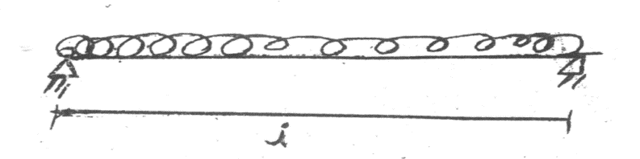
(CO-3, PO-3, Level-4) [4]
2.Find the maximum deflection and the maximum slope for the beam loaded as shown in fig.
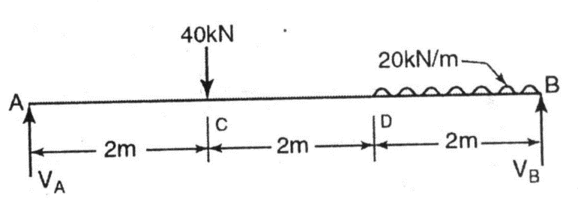
(CO-3, PO-3 , Level-5) [4]
3.The allowable shear stress in brass is 80 N/mm² and in steel 100 N/mm². Find the maximum torque that can be applied in the stepped shaft in fig. 6.8 a. Find also the total rotation of free end w.r.t. the fixed end if G_{b}= 40 KN/mm² and G_{s}= 80 KN/mm².
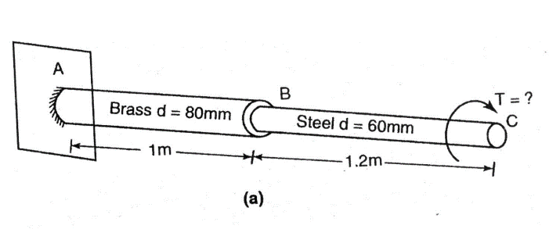(CO4-PO-3, Level-5)[4]

4.Derive the Torsion Equation. (CO-4, PO-1, Level-3) [4]
5.Draw the Mohr’s stress circle for direct stresses of 65 MN/m² (Tensile) and 35 MN/m² (Compressive) and estimate the magnitude and direction of the resultant stresses on plane making angles of 20º and 65º with the plane of the first principal stress. Find also the normal and tangential stresses on these planes. (CO-5, PO-3, Level-5) [4]

