Program: B. Tech | Faculty Name: Dr. S. S. Bishoyi | Sem.: 4th
Cs ourse Name: Discrete Mathematics | Course Code: B022411(014) | Max Marks: 20

Assignment- 1

- Prove the validity of the following argument “If I get the job and work hard, then I will get promoted. If I get promoted then I will be happy. I will not be happy. Therefore, either I will not get the job or I will not work hard.” (Co-1, Po-1, Level-2)

- Prove that for every element a and b of a Boolean algebra
- ${\left(a+b\right)}^{'}=a^{'}.b'$
- ${\left(a.b\right)}^{'}=a^{'}+b'$ (Co-1, Po-2, Level-2)

- Obtain the Disjunctive Normal form of the following functions (Co-1, Po-3, Level-3)
$$F\left(x,y,z\right)=\left(x+y\right)+\left(x+z^{'}\right)+\left(y+z'\right)$$
- Show that
$\frac{1}{1.2}+\frac{1}{2.3}+\frac{1}{3.4}+…………+\frac{1}{n(n+1)}=\frac{n}{n+1} ,∀n≥1$
(Co-4, Po-2, Level-2)
- Solve the recurrence relation
$a_{n+2}-5a_{n+1}+6a_{n}=2,$ with intial condition $a_{0}=1 and a_{1}=-1$ by characteristics root method. (Co-4, Po-1, Level-2)

Program: - B.Tech | Faculty Name:- Mrs.Lincy Mendonza | Sem:- 4th Sem
Course Name:- DAA | Course Code: - B022414(022) | Max Marks:-20

Assignment- 1
Even Session (Jan-June 2022)
Note: - Each Question carries 4 marks.
1.Write the algorithm for insertion sort and also compute its worst case time complexity. (CO-1, PO-1, Level-2) [4] 2.Explain merge sort .(CO-2,PO-1, Level- 2) [4]
3. Write the algorithm for Binary search and also compute time complexity. (CO-1, PO- 2, Level-2) [4]
4..Explain quick sort. (CO-2, PO- 2, Level-2) [4]
5.use greedy approaach to find optimal solution to Knapsack problem
max.weight W= 10 units ,total items N=4,value of items v[]={10,40,30,50},w[]={5.4,6,3} (CO-2 PO- 1, Level-3) [4]

Program: - B. Tech | Faculty Name:- Rupesh Mude | Sem:- 4th
Course Name:- oops in Java | Course Code: -B022414(022) | Max Marks:-20
Assignment- 1
(Even Sem 2022)

Note: - Each Question carries 4 marks.
1. Describe the java I/O Classes and Interfaces. (CO-3, PO-3, Level-2)
2. What is Constructor? Explain types of constructor CO-3, PO-3, Level-2,3)
3. Explain the life cycle of thread? In how many ways can a thread be created in java. (CO-4, PO-2, Level-2)
4. Explain inheritance in java with suitable example? (CO-4, PO-1, Level-1)
5. Explain the following. (CO-3, PO-2 , Level-1)
- Init()
- Start()
- Stop()
- Destroy()

Sub Name: CSA | Faculty Name: Ms. Divyani | Sem: 4th
Program: B.TECH CSE | Course Code: - | Max Marks:  -20

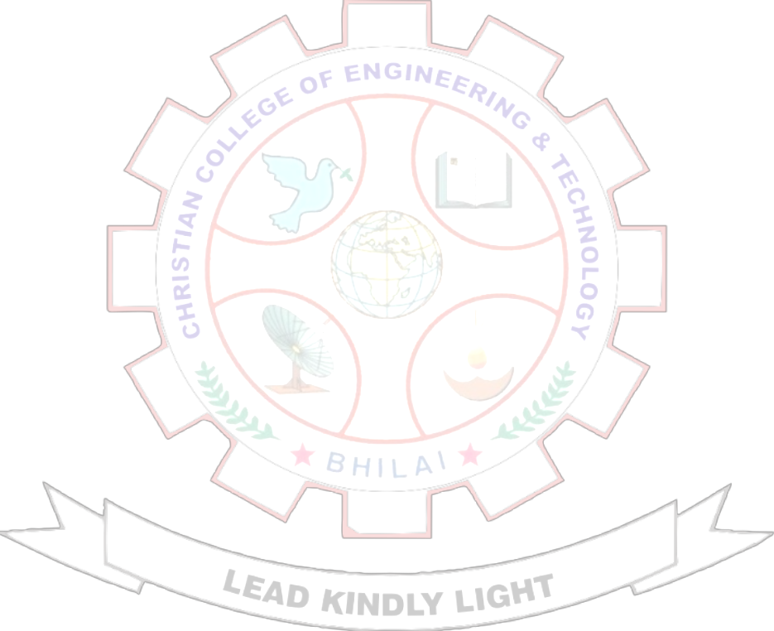Assignment –I (JAN-JUN 2022)

- Explain various technologies used in memory design? 4
- Explain memory hierarchy? 4
- Explain virtual memory ,how its work? 4
- Explain Addressing mode and its type? 4
- The avg memory access time for a machine with a cache hit rate of 80% where the cache access time is 5ns and main memory access time is 100ns find out total avg, time for parallel and sequential memory? 4

Sub Name: CG | Faculty Name: Mrs. Amrita Banjare | Sem: 4th
Program: B.TECH CSE | Course Code: - B022413 (022) | Max Marks:  -20
